**CABer**

**CSE2004 Database Management System**

**Project Report**

**Submitted by**

*Pranav Raj 19BPS1041*

*Kunal Kumar Jha 19BCE1212*



**School of Computer Science and Engineering**

**April 2020**

**Table of Content**

Page Number

Introduction - 3

Project Details - 4

E-R Diagram - 5

E-R to Relational model - 6

Normalized Table - 7

Software’s and Languages Used - 8

Description of each page - 9

Overview of tables - 19

**Introduction**

A database management system (DBMS) refers to the technology for creating and managing databases. Basically, DBMS is a software tool to organize (create, retrieve, update and manage) data in a database.

The main aim of a DBMS is to supply a way to store up and retrieve database information that is both convenient and efficient. By data, we mean known facts that can be recorded and that have embedded meaning. Normally people use software such as DBASE IV or V, Microsoft ACCESS, or EXCEL to store data in the form of database.

Database systems are meant to handle large collection of information. Management of data involves both defining structures for storage of information and providing mechanisms that can do the manipulation of those stored information. Moreover, the database system must ensure the safety of the information stored, despite system crashes or attempts at unauthorized access.

This project is aim at computerizing the manual process of wedding system. Front end and backend are implemented using HTML and MySQL respectively. Along with the php program code.

**TECHNICAL ASPECTS**

* **HTML:** Hyper Text Markup Language (HTML)is a simple markup system

used to create hypertext documents that are portable from one platform to

another.

* **CSS:** Cascading Style Sheets, fondly referred to as CSS, is a simple

designed language intended to simplify the process of making web pages

presentable.

* **PHP:** PHP started out as a small open source project that evolved as more

and more people found out how useful it was.

* **MySQL:** MySQL is an open-source relational database management

System that works on many platforms. It provides multi-user access to

Support many storage engines and is backed by Oracle.

**CABer**

**What is CABer?**

CABer is derived from an idea that during the vacation all the hosteller find it very difficult to find the partner for cab and at time when the book their flight to their respective cities. This database will help will them to find the companion for their long homecoming journey and will help to share the huge cash demanded by the cab driver.

The purpose of the project entitled as “CABER” is to computerize the Front Office Management of CAB to develop software which is user friendly simple, fast, and cost-effective. It deals with the collection of student’s information, journey details, etc. Traditionally, it was done manually. The main function of the system is to register and store student details and journey details and retrieve these details as and when required, and also to manipulate these details meaningfully System input

contains student details, there journey details, while system output is to get these details on to the screen. The main motive is to display the journey partner for each student

**What does CABer do?**

The objective is to show every name and contact numbers of those student whose time and destination (e.g. Chennai railway station, domestic airport, etc.) clashes with the other students. This will help them to share their cab fares and take the flight with their friends going to same place.

**Why you should use CABer?**

1. This will minimize the consumption of huge amount of fuel and also minimizes the pollution.

2. This will also save the money of students and give a good company for the journey.

**ER diagram**

ER Diagram is a visual representation of data that describes how data is related to each other. In ER Model, we disintegrate data into entities, attributes and setup relationships between entities, all this can be represented visually using the ER diagram.

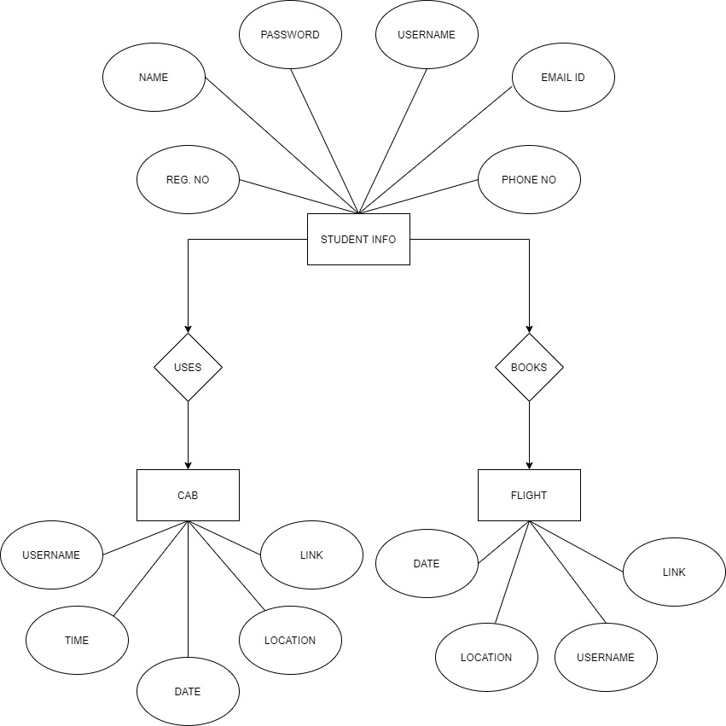In this diagram we can clearly see that the main table is student which has the attributes which are mentioned below .Then there two more tables cab and flight for taking the details of the student who are willing to take cab or flight respectively .The attribute of those tables are also listed below. There is relation between student table with cab and flight table through their primary keys. Every student is related with cab and flight. In the cab table and flight table the username is these tables are foreign keys with reference to the two username in student table.

**ER diagram to relational model**

After transforming the above given ER diagram to relational model, we get three tables

1. Entity **student** has attributes as username, name, regno, password, phone no., email id. Here the username will be the primary key.

**Student** (Username, Name, Regno (Registration Number), Password, Phone No., Email Id)

1. Entity **cab** has attributes as username (which is foreign key from table student), time, date, location.

**CAB** (Username, Time, Date, Location)

1. Entity **flight** has attributes as username (which is foreign key from table student), destination.

**Flight** (Username, Date, Destination)

In this project we are considering any table for the relationship table as we already using the foreign keys so using the relationship table will be redundancy of the tables and data.

**Normalized tables**

1. **Student Table** follows**:**

* **1NF** each attribute of the table is having atomic values.
* **2NF** no non-prime attribute is dependent on the proper subset of any candidate key of table. Candidate keys are Regno, Email Id.
* **3NF** [transitive functional dependency](https://beginnersbook.com/2015/04/transitive-dependency-in-dbms/) of non-prime attribute on any super key is not present.
* **BCNF** every functional dependency is such that super keys in related to other attributes.

1. **Cab Table** follows**:**

* **1NF** each attribute of the table is having atomic values.
* **2NF** no non-prime attribute is dependent on the proper subset of any candidate key of table. This table has no candidate keys.
* **3NF** [transitive functional dependency](https://beginnersbook.com/2015/04/transitive-dependency-in-dbms/) of non-prime attribute on any super key is not present.
* **BCNF** every functional dependency is such that super keys in related to other attributes.

1. **Flight Table** follows**:**

* **1NF** each attribute of the table is having atomic values.
* **2NF** no non-prime attribute is dependent on the proper subset of any candidate key of table. This table has no candidate keys.
* **3NF** [transitive functional dependency](https://beginnersbook.com/2015/04/transitive-dependency-in-dbms/) of non-prime attribute on any super key is not present.
* **BCNF** every functional dependency is such that super keys in related to other attributes.

Hence, we didn’t need to divide the tables as they were already normalized till BCNF.

1. **Student** (Username, Name, Regno (Registration Number), Password, Phone No, Email Id)

2. **CAB** (Username, Time, Date, Location)

3. **Flight** (Username, Date, Destination)

**Software’s used**

* Sublime text (as text editor)
* Chrome Web Browser (to execute the codes)
* WampServer64 (to run the php code and connect to phpMyAdmin and maintain the database)

**Programming languages used**

* HTML5
* CSS3 and Bootstrap
* JavaScript
* SQL
* PHP

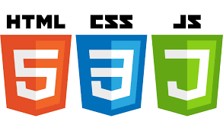



**Description of each page of CABer.**

1. **Homepage.**

On this homepage who can either login if you have already had an account or you can register yourself and have an account. Both these are present on the header of the page. The about us button will give you more information about the features of the website which are included above. The Develop button will be show our names i.e. Pranav Raj and Kunal Kumar Jha.

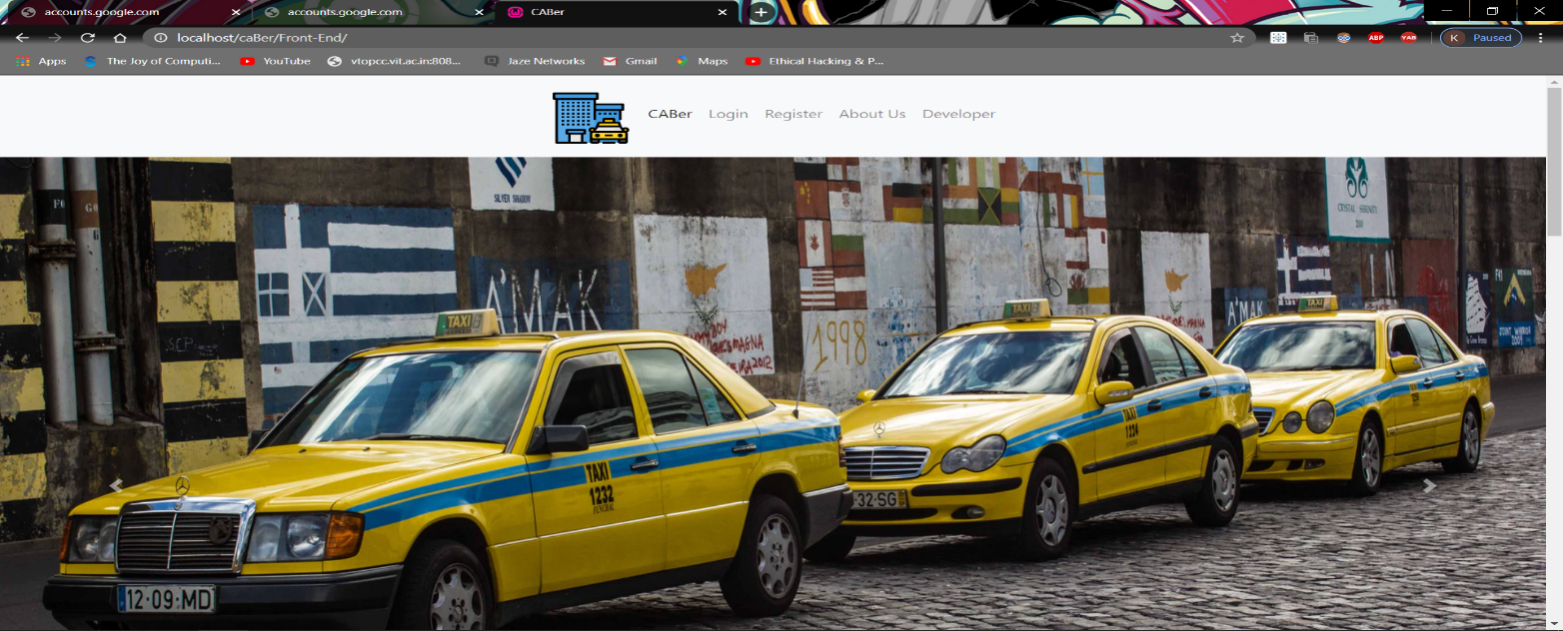

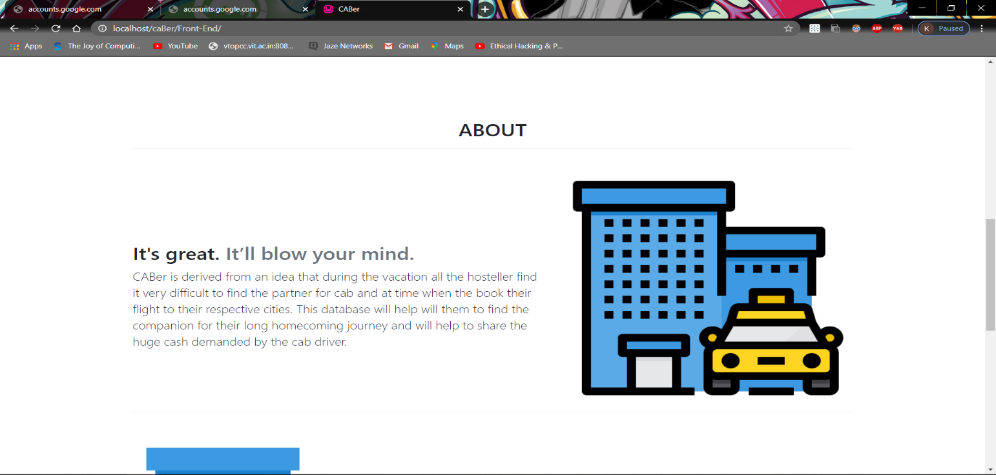

**Fig-1**

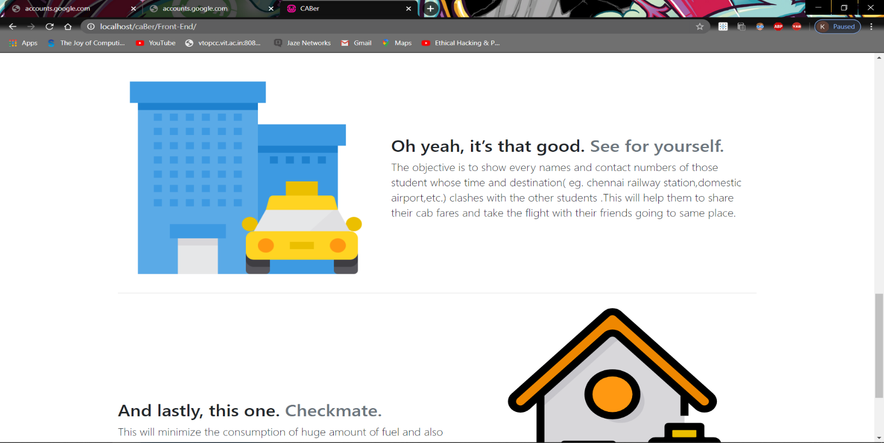 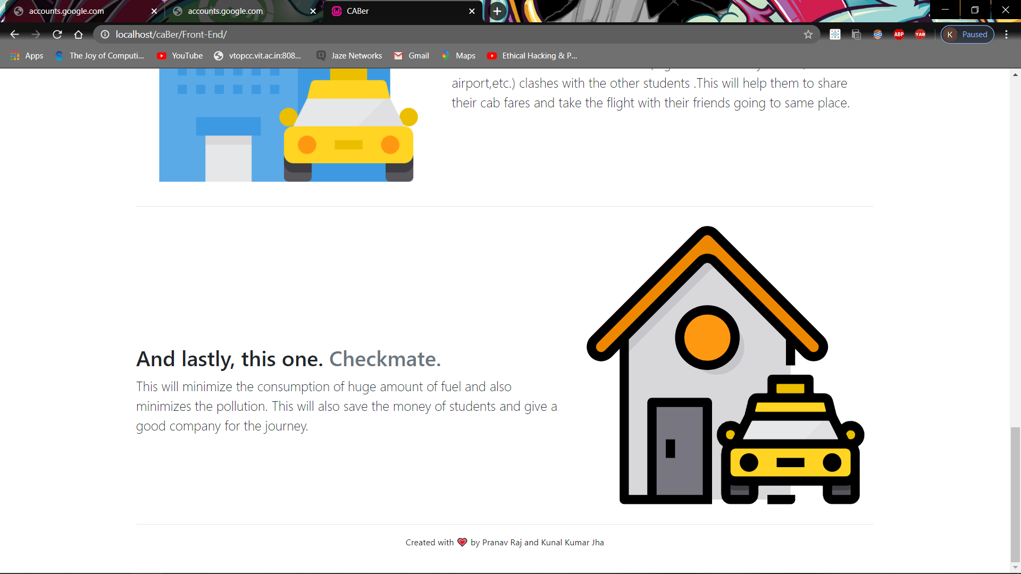

**Fig-2**

**Fig 1-2 These are the screenshots of homepage.**

1. **Login Page.**

On this page you can enter your credentials. If your credentials are correct it will take you to next page. Else it will give you the alert according to mistakes you have made in entering. If you don’t have an account you can now also go directly to signup page and register for yourself.

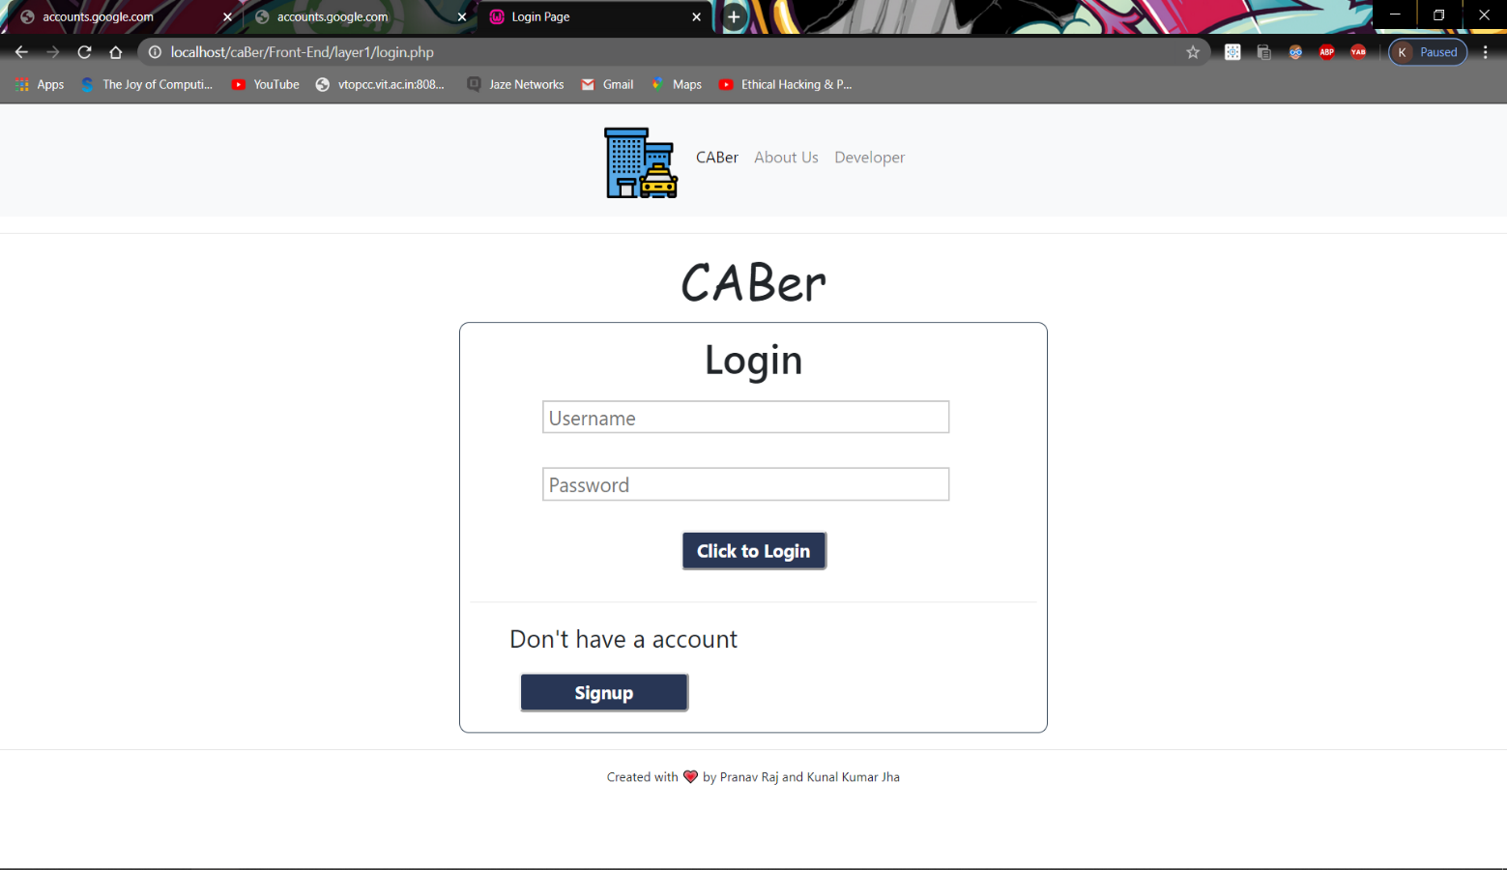

**Fig-3 This is a screenshot of login page.**

1. **Signup Page.**

On this page you need to give the information about you i.e. Name, Reg no, Username, Phone No, email id and password about you for the registration. This page will also verify if your password and confirm password is same. Using the login button, you can directly visit to login page.

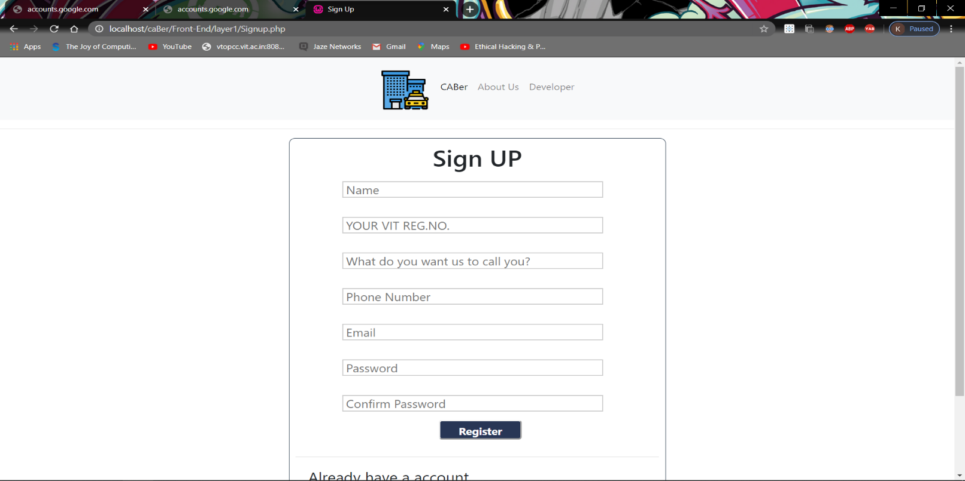

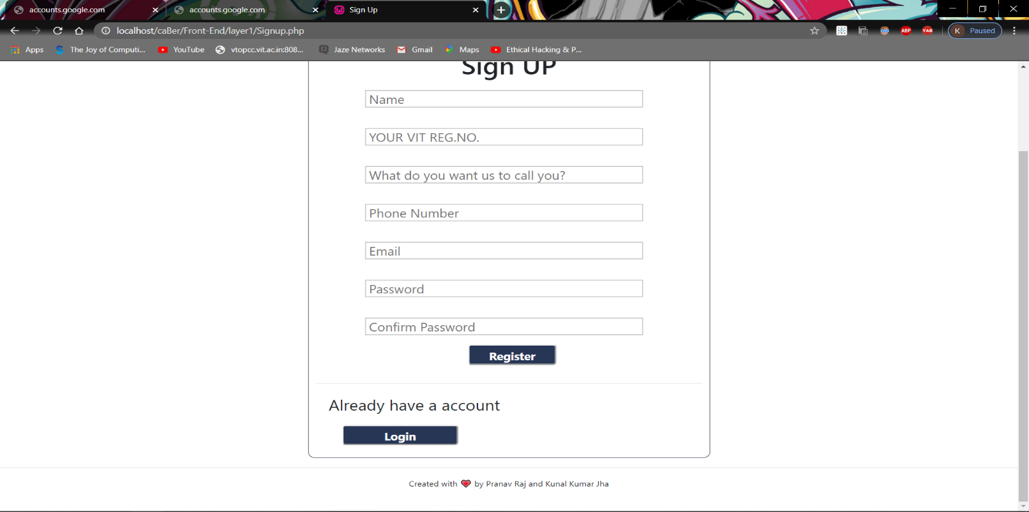

**Fig-4 This is a screenshot of signup page.**

1. **Homepage 2**

You will reach this page if your credential is correct on login page. On this page you can see your username on the top right corner which you have provided while registering in the signup page. There is a button in center of this page which have 4 drop down menus which have the options for your cab registration and flight registration and also options for result of cab registration and flight registration. On choosing the particular option you will reach that page. This page also has the logout button when you are completed with your enquiry about your journey partner.

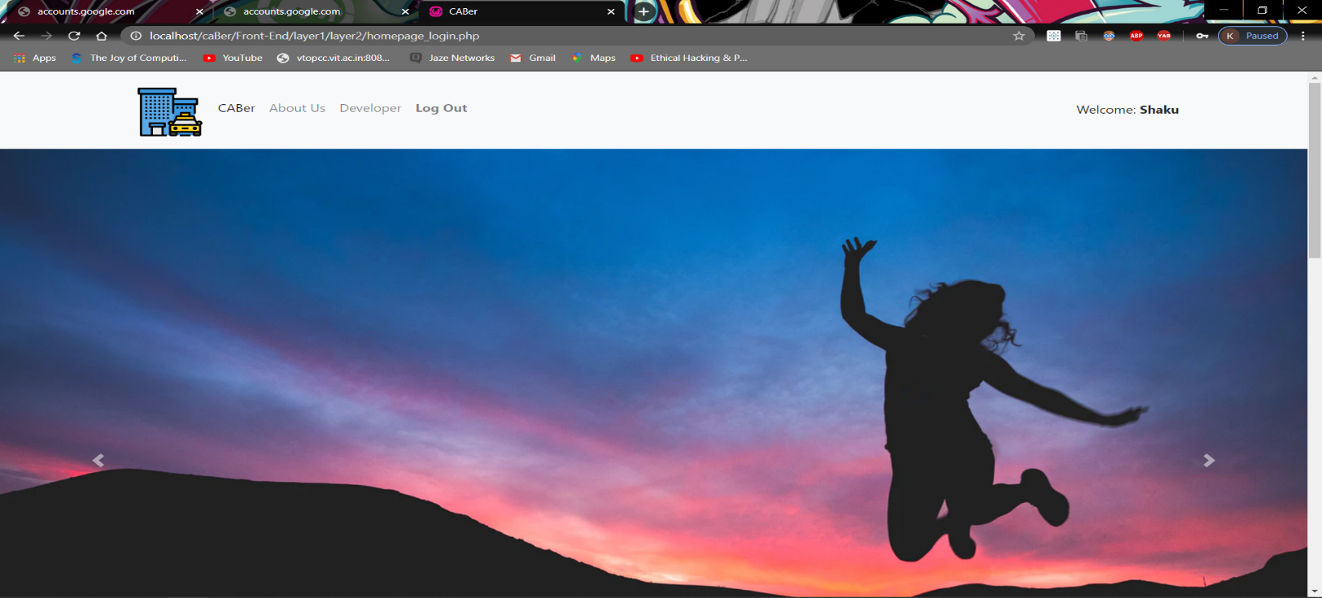

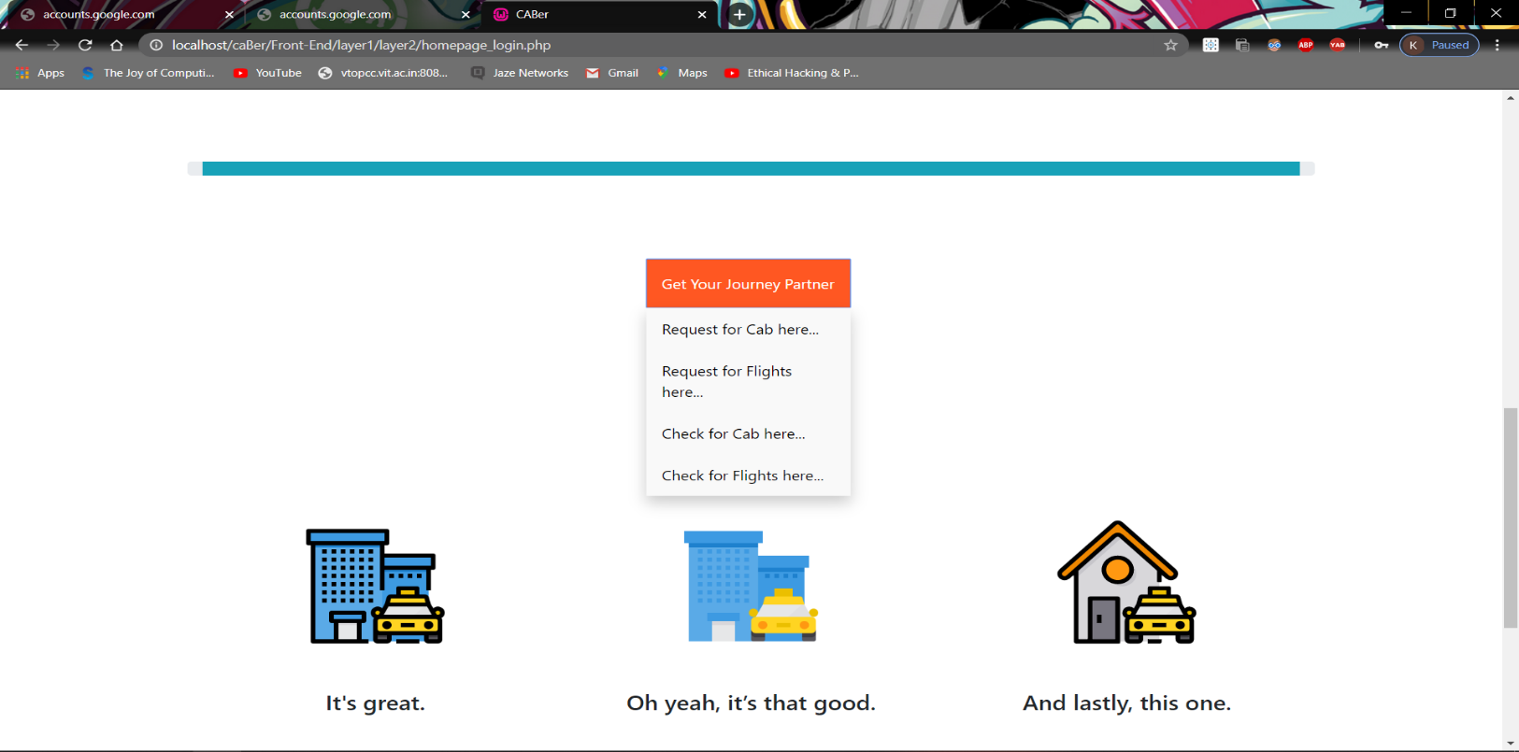

**Fig-5 Here you can see the get your journey partner button**

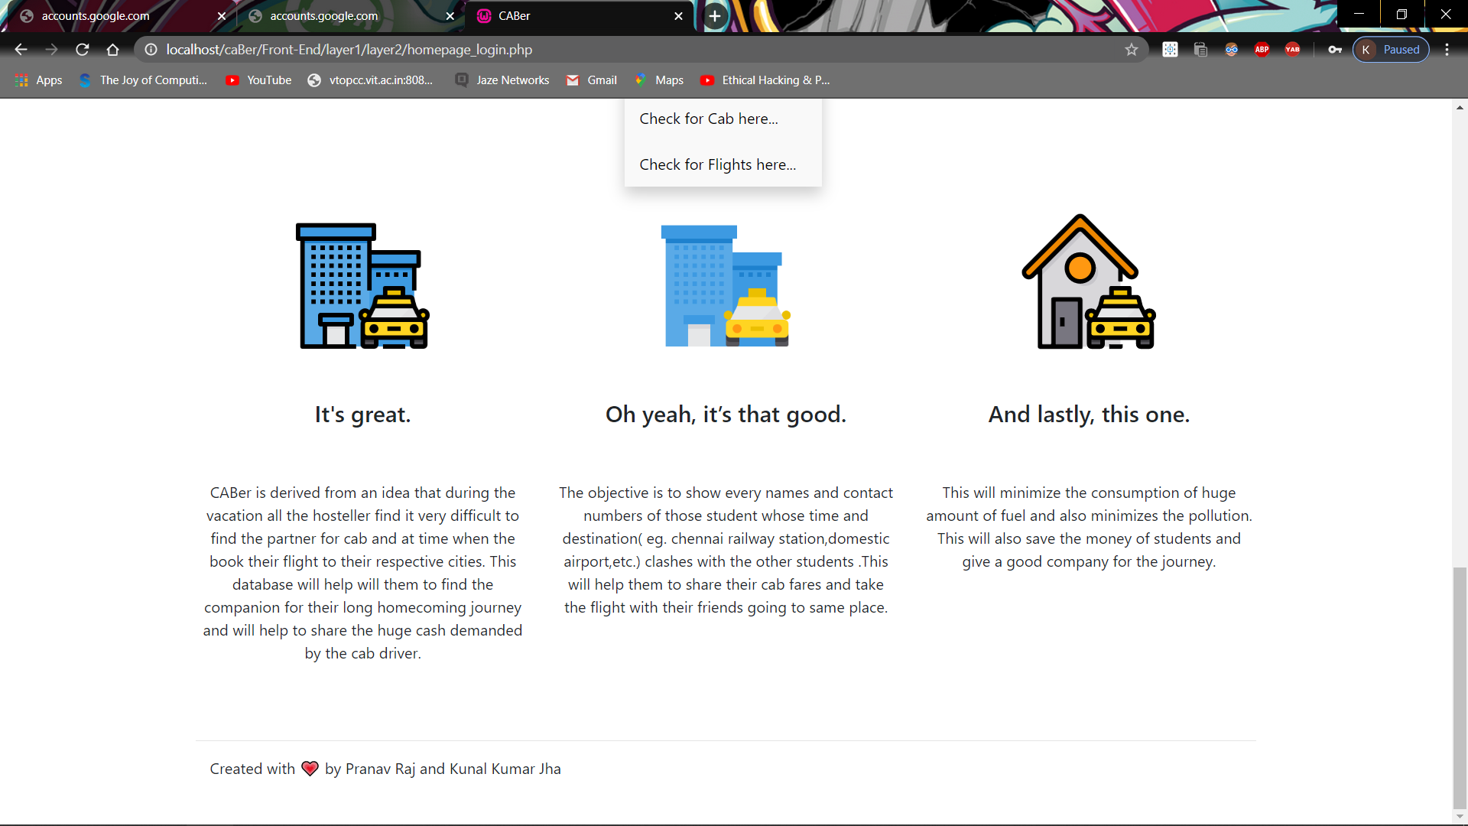

**Fig-6 Here you can see the about us.**

**Fig 6-7 These are screenshots of homepage2**

1. **Request for cab page.**

On this page you will have the option to choose the location where you want to go and the date and time on which you have to travel. And hit start finding friends. Your data will be stored in the database. Even on this page you will be able to see the username of the user and logout button if your enquiry is over for finding travel partner.

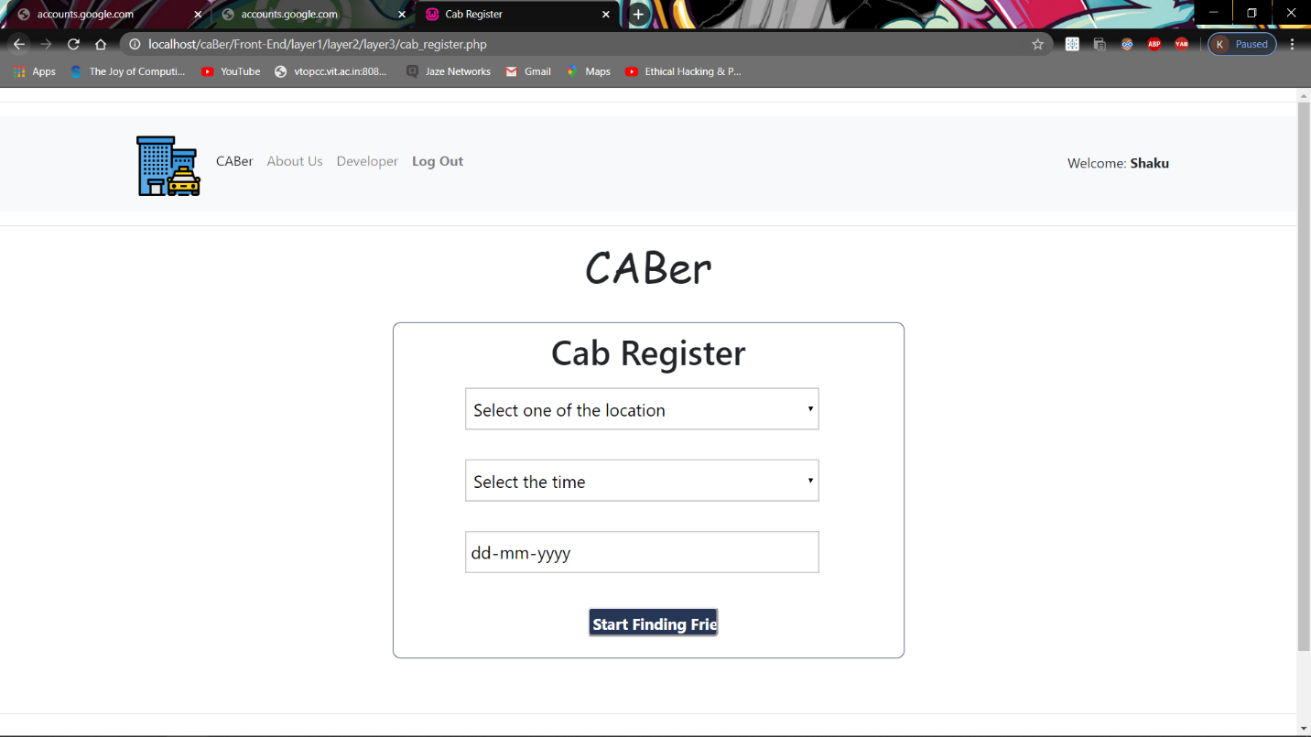

**Fig-8 This is a screenshot of request for cab page.**

1. **Request for flight page.**

On this page you will have the option to choose the location where you want to go and the date on which you have to travel. And hit start finding friends. Your data will be stored in the database. Even on this page you will be able to see the username of the user and logout button if your enquiry is over for finding travel partner.

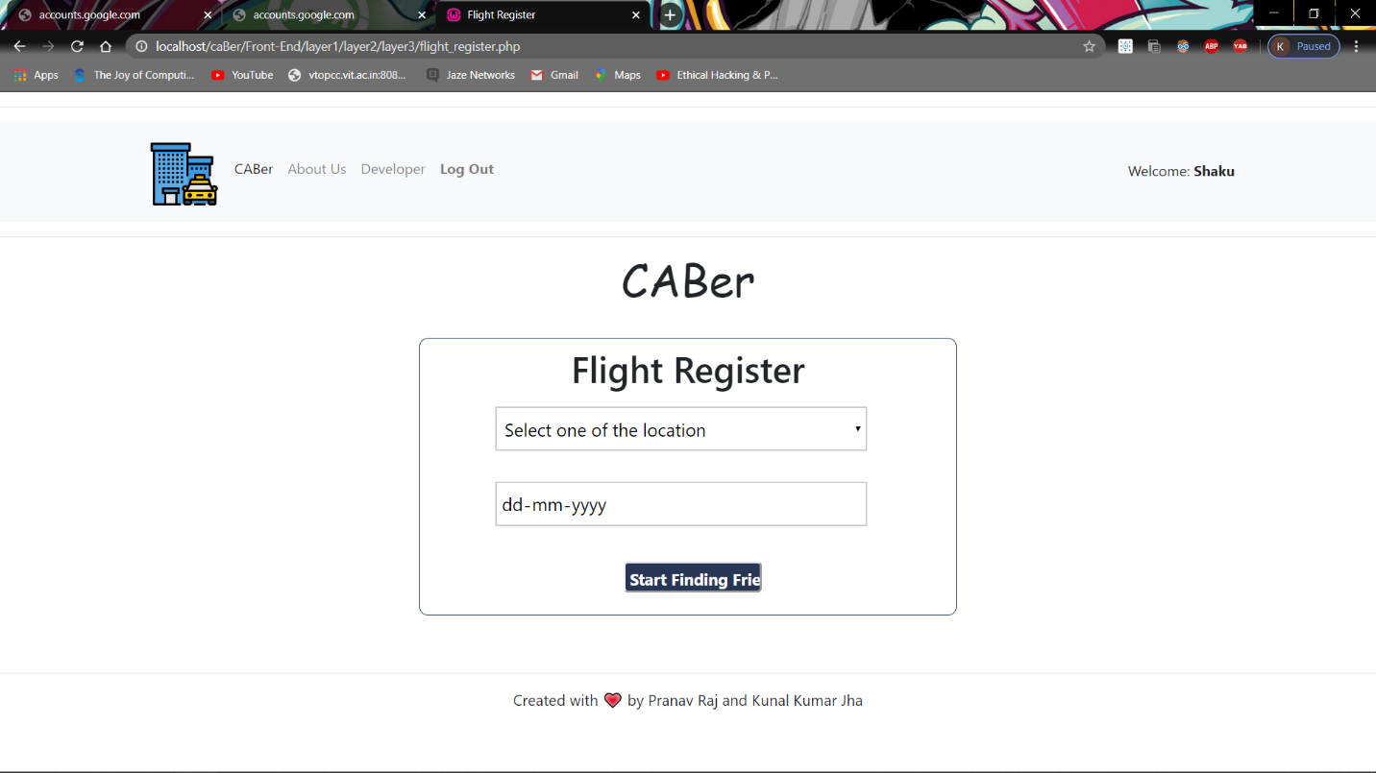

**Fig-9 This is a screenshot of request for flight page.**

1. **Results for cab registration page.**

On this page you will see the location where you want to go and the date on which you have to travel you have select will cab registration along with the information of other people who also requested to go on same location on same date and time. Your data will be shown from the data in database. Even on this page you will be able to see the username of the user and logout button if your enquiry is over for finding travel partner.

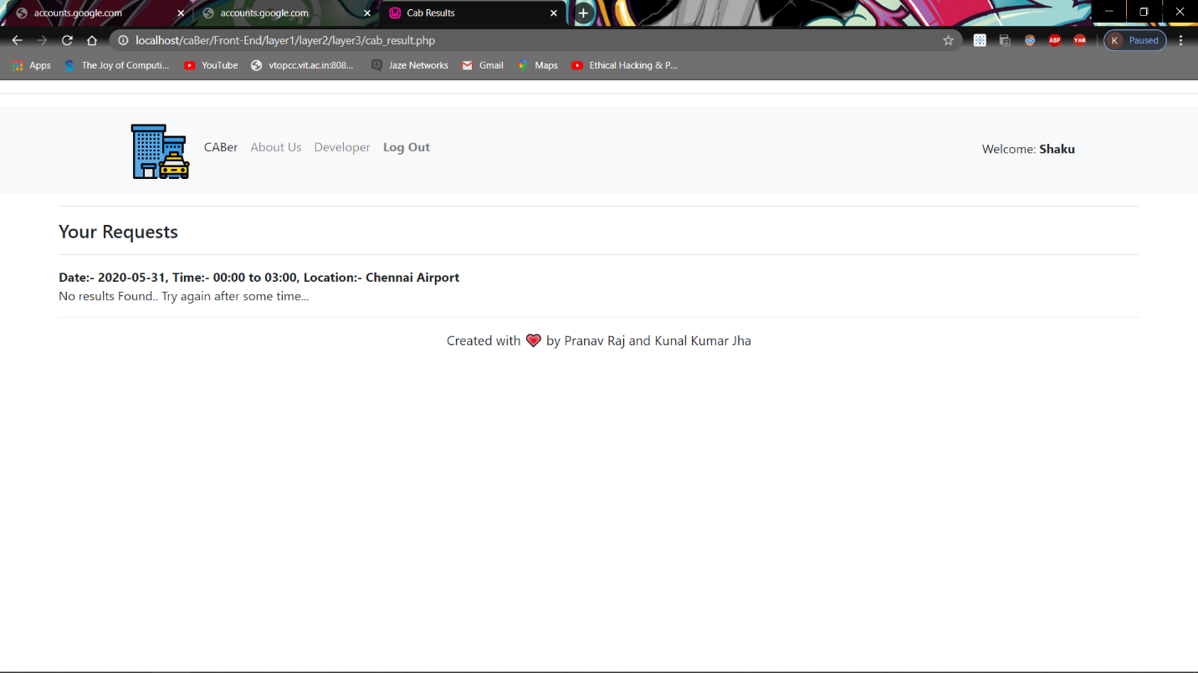

**Fig-10 This is a screenshot of result for cab registration page.**

1. **Results for flight registration page.**

On this page you will see the location where you want to go and the date on which you have to travel you have selected will flight registration along with the information of other people who also requested to go on same location on same date. Your data will be shown from the data in database. Even on this page you will be able to see the username of the user and logout button if your enquiry is over for finding travel partner.

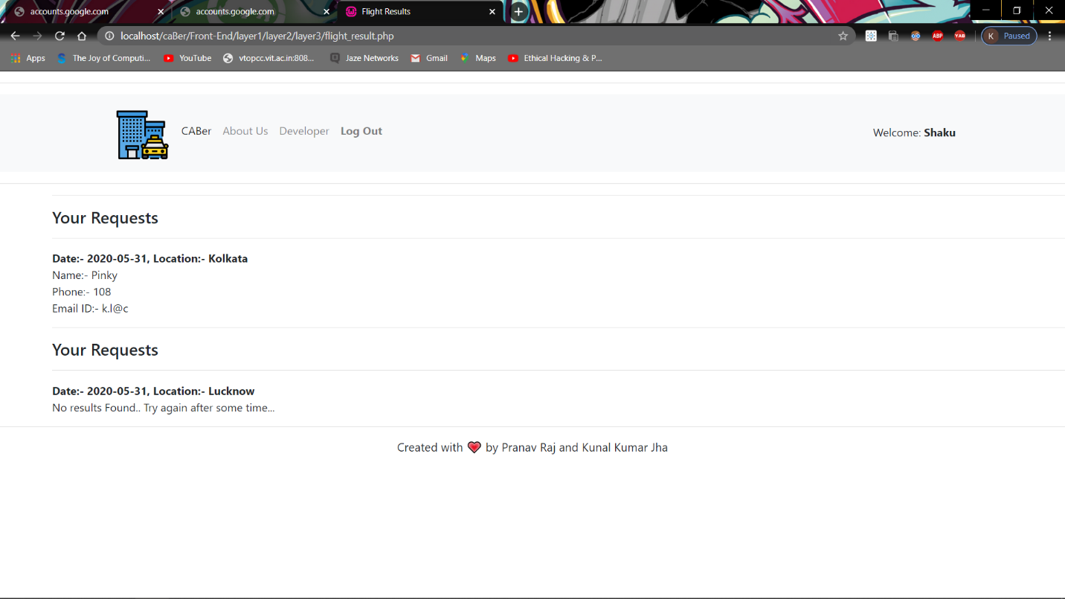

**Fig-11 This is a screenshot of result for flight registration page.**

**This is the overview of all the tables and their attributes used in the CABer.**

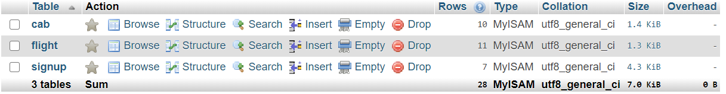

**Fig-12 List of all the tables in CABer Database.**

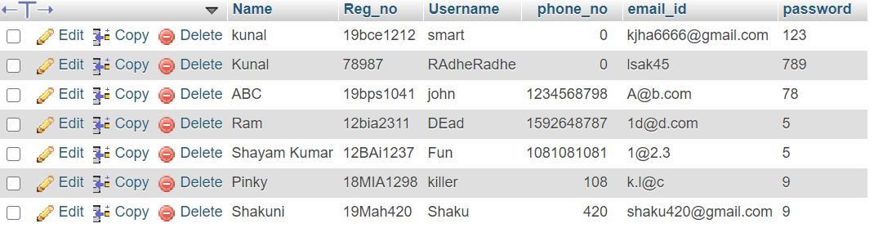

**Fig-13 This is Student table having all login details**

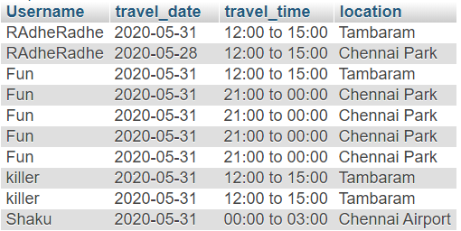

**Fig-14 This is Cab table having all location details about cab along with date and time.**

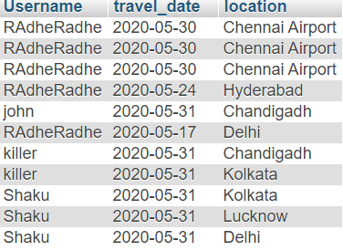

**Fig-15 This is Flight table having all location details about flights along with date.**